**GASOLINE AND DESIEL WEEKLY RETAIL PRICES SQL QUERIES**

**KPI’s**

1. **All Grades All Formulations Gasoline By country**  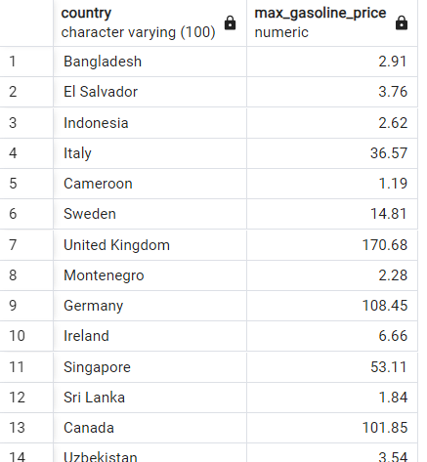
2. 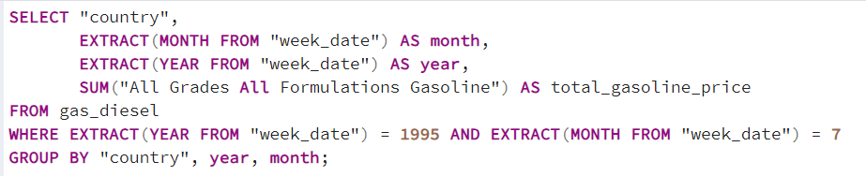**All Grades All Formulations Gasoline By country in June & July 1995**

1. **All Grades Conventional Gasoline By country in 2020 first quarter**

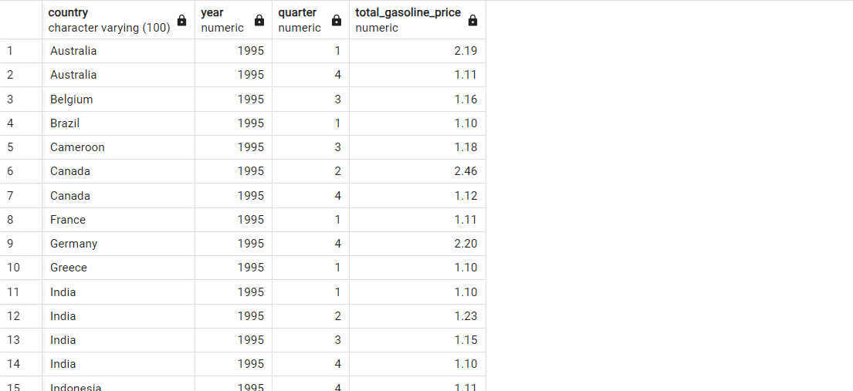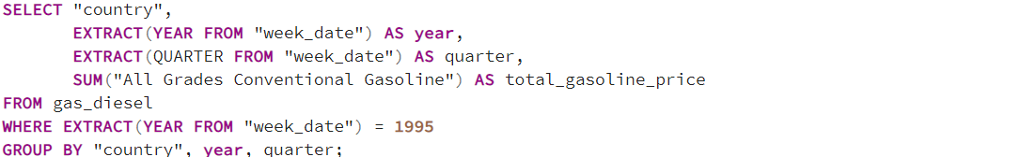

1. 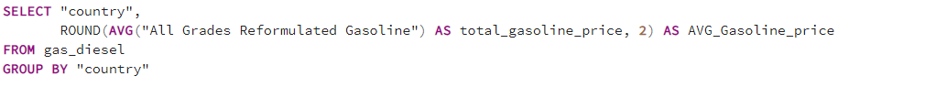**AVG All Grades Reformulated Gasoline By country**

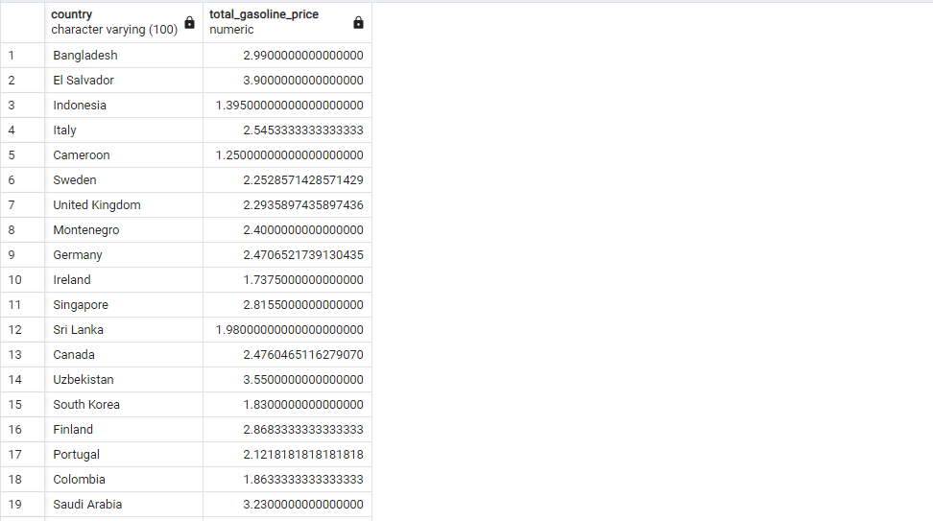

1. 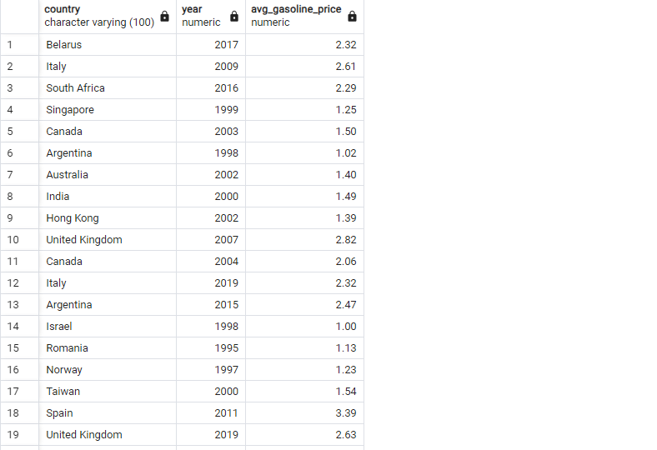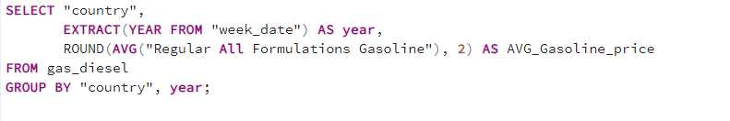**AVG Regular All Formulations Gasoline By year and country**
2. **Total retail prices of Premium Conventional Gasoline by month**

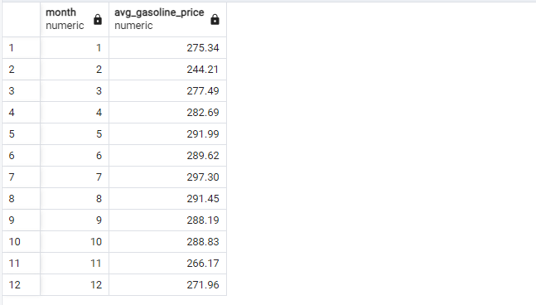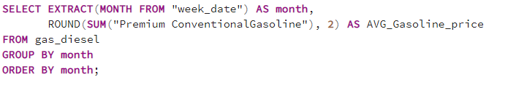

1. **No 2 Diesel AVG Retail Prices By years**

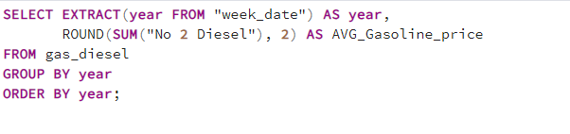

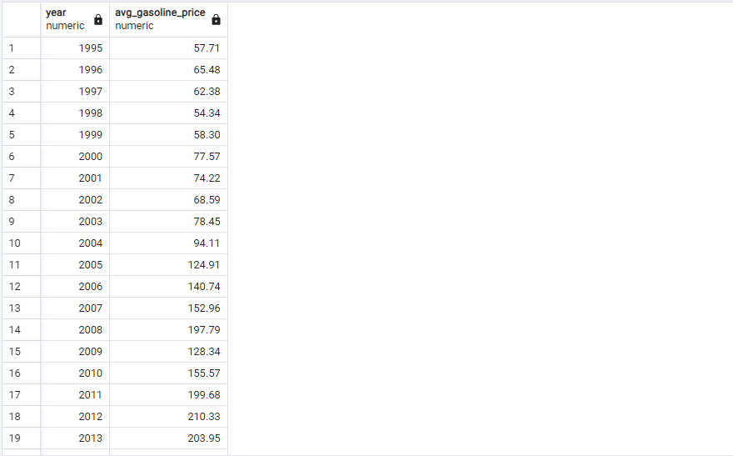

**No 2 Diesel Retail Prices by each month in 2018 and 2019**

